

|  |
| --- |
| **SOCIAL MEDIA ENGAGEMENT**  IMG_256IMG_256**ANALYSIS REPORT** |



**Data Analysis Questions**

1. Engagement Patterns:

- What has been the trend in engagement rates on Stanbic IBTC Bank's LinkedIn and Twitter platforms over the past three years?

- How do different content types (photos, videos, text) individually contribute to the overall engagement on both LinkedIn and Twitter?

2. Tagging Impact:

- Is there a significant difference in engagement metrics between posts with tags and those without on LinkedIn and Twitter?

- Do posts with tags perform differently in terms of reach and engagement compared to posts without tags?

3. Correlation Analysis:

- What is the nature and strength of the correlation between engagement rates and shares on both LinkedIn and Twitter?

- Is there a correlation between the presence of tags and the number of post link clicks on LinkedIn and Twitter?

4. LinkedIn vs. Twitter Metrics:

- How does the click-through rate on LinkedIn compare to Twitter, and what factors contribute to these differences?

- Despite LinkedIn having a lower average post link click rate, does the platform still yield a higher overall engagement compared to Twitter?

5. LinkedIn Insights:

- What factors contribute to the observed engagement peaks on LinkedIn between 12 pm and 3 pm and 3 pm to 6 pm?

- How does the posting frequency of Blessing Ubah and Sophia Amuka correlate with their respective engagement rates on LinkedIn?

6. Twitter Insights:

- What explains the multiple peak engagement times on Twitter, particularly between 7 am to 11 am, 4 pm to 7 pm, and 7 pm to 9 pm?

- Is there a relationship between posting frequency and engagement rates for the top contributors on Twitter, namely Sophia Amuka, Blessing Ubah, and Aramide Salami?

7. LinkedIn Click-Through Rate Trends:

- How has the click-through rate on LinkedIn evolved over the past three years, and what external factors may have influenced these trends?

- Are there specific content formats or contributors that consistently drive higher click-through rates on LinkedIn?

8. Twitter Click-Through Rate Trends:

- Similarly, how has the click-through rate on Twitter evolved, and are there notable periods or events influencing these trends?

- Do certain types of content or contributors consistently contribute to higher click-through rates on Twitter?

9. LinkedIn Document Content:

- What might be the reasons behind the observed lower engagement of document-type content on LinkedIn?

- Are there specific topics or types of documents that perform better than others on LinkedIn?

10. Overall Strategy Implications:

- Based on the insights, what recommendations can be derived for optimizing the overall social media strategy of Stanbic IBTC Bank for future digital marketing campaigns?

- How can the bank balance platform-specific strategies while maintaining a cohesive and brand-consistent presence across both LinkedIn and Twitter?

**INSIGNTS DERIVED FROM THE DASBOARD**

**Comprehensive Social Media Analytics Report:**

1. Over the course of the last three years (2020-2023), Stanbic IBTC Bank has exhibited an impressive social media performance, notably achieving a striking engagement rate of 125.3, amassing 67.8k likes, 11.5k shares, and a substantial 7.9 million impressions on LinkedIn and Twitter. What stands out is the discernment that photo content consistently outperforms video and text, echoing the importance of visual appeal in driving engagement.
2. An intriguing finding surfaces in the observation that high-engagement posts tend to eschew tags. This suggests a unique characteristic of Stanbic IBTC Bank's audience, where tagging does not significantly influence the content's reach. However, a positive correlation between engagement rates and shares unveils a vital insight — heightened engagement directly corresponds to increased shares and link clicks.
3. LinkedIn, as a professional platform, manifests distinct trends. With a robust click-through rate of 33.21, it outshines Twitter's 2.96. Paradoxically, Twitter records a higher average post link click rate (87.5) compared to LinkedIn (32.1), emphasizing the need for platform-specific content strategies.
4. LinkedIn CTR (33.21) vs. Twitter CTR (2.96): LinkedIn boasts a substantially higher CTR compared to Twitter, indicating a greater efficacy in converting engagements into clicks on the professional networking site.
5. Twitter's Higher Average Post Link Clicks (87.5) vs. LinkedIn (32.1): Despite the lower CTR on Twitter, the platform records more average post link clicks. This suggests that, while LinkedIn has a more focused audience for clicking through, Twitter sees a higher volume of click-throughs.

**LinkedIn Insights:**

1. LinkedIn's growth is noteworthy, with a 27.2% surge in engagement rates, a 26.7% increase in likes, and a substantial 68.0% rise in comments.

1. Blessing Ubah emerges as a prolific contributor with 2.4k posts, closely followed by Sophia Amuka, who posted 858 contents.
2. Strategically, peak engagement on LinkedIn is observed between 12 pm and 3 pm and 3 pm to 6 pm.
3. Blessing Ubah's content shines between 4 pm and 6 pm, aligning with the professional nature of LinkedIn. Document-type content, however, shows the least engagement, indicating a preference for alternative formats on this platform.

**Twitter Insights:**

1. Twitter undergoes a considerable uptick in engagement metrics — a 40.8% rise in the engagement rate, a 36.0% increase in likes, and a significant 54.9% surge in comments.
2. Sophia Amuka stands out as the most active contributor with 2.5k posts, followed by Blessing Ubah (251 posts) and Aramide Salami (223 posts).
3. Peak engagement on Twitter is discernible between 7 am to 11 am, 4 pm to to 9 pm. These timeframes align with users' likely active periods during the day.

**RECOMMEDATIONS**

**Recommendations for Optimized Social Media Strategy:**

1. **Visual-Centric Content Focus:** Leverage the trend identified in high engagement with photo content. Prioritize visually appealing graphics and images in your digital marketing campaigns across both LinkedIn and Twitter.
2. **Strategic Tag Usage:** While the analysis suggests that high-engagement posts often lack tags, experiment with strategic tagging to assess its impact. A controlled and targeted approach to tagging may yield valuable insights into audience preferences.
3. **Diversified Content Formats:** Recognize the varying engagement with content formats on LinkedIn. While photo content excels, consider experimenting with diverse formats to maintain a dynamic and engaging feed. Video content can provide a rich and immersive experience.
4. **Time-Optimized Posting:** Align posting schedules with peak engagement times on each platform. For LinkedIn, focus on the time blocks between 12 pm and 3 pm, as well as 3 pm to 6 pm. On Twitter, capitalize on the active periods from 7 am to 11 am, 4 pm to 9 pm.
5. **In-depth LinkedIn Analysis**: Given the professional nature of LinkedIn, continue analyzing Blessing Ubah's successful engagement period (4 pm to 6 pm). Tailor content to align with post-work hours, understanding that professional audiences may engage more after office hours.
6. **Platform-Specific Optimization:** Customize content for each platform based on their unique characteristics. LinkedIn's professional ambiance demands polished and informative content, while Twitter's dynamic nature allows for more real-time and conversational interactions.
7. **Strategic Tag Usage on LinkedIn:** Although tags may not significantly impact reach, consider employing them selectively on LinkedIn. Test their effectiveness in driving targeted engagement and brand visibility within the professional community.
8. **Interactive Content for Twitter:** Given the increased engagement on Twitter, explore interactive content formats such as polls, quizzes, or threads. These can foster greater audience participation and contribute to higher interaction rates.
9. **Regular Performance Audits:** Conduct regular assessments of your social media performance. Keep an eye on emerging trends, audience behavior shifts, and adapt the strategy accordingly. Social media is dynamic, and staying agile is key to sustained success.
10. **Investment in LinkedIn Growth:** Given the significant positive growth trends on LinkedIn, consider allocating additional resources and content strategies to capitalize on this platform's potential. This may involve increased frequency of posts or more targeted advertising.
11. **LinkedIn Content Optimization:** Capitalize on LinkedIn's impressive CTR by optimizing content for more clickable elements. Incorporate compelling call-to-action (CTA) language, directing the audience to relevant links, articles, or landing pages.
12. **Enhanced Twitter Call-to-Action**: Given Twitter's higher average post link clicks, focus on crafting concise yet impactful CTAs in tweets. Encourage immediate actions, such as visiting a webpage, attending an event, or participating in a discussion.
13. **Platform-Specific CTA Strategies:** Tailor CTA strategies for each platform. On LinkedIn, emphasize the professional benefits and insights, while on Twitter, create urgency and appeal to the dynamic, real-time nature of the platform.

By implementing these recommendations, Stanbic IBTC Bank can refine its social media strategy, ensuring it aligns with audience preferences, platform dynamics, and emerging trends, thereby maximizing the impact of its digital marketing campaigns.

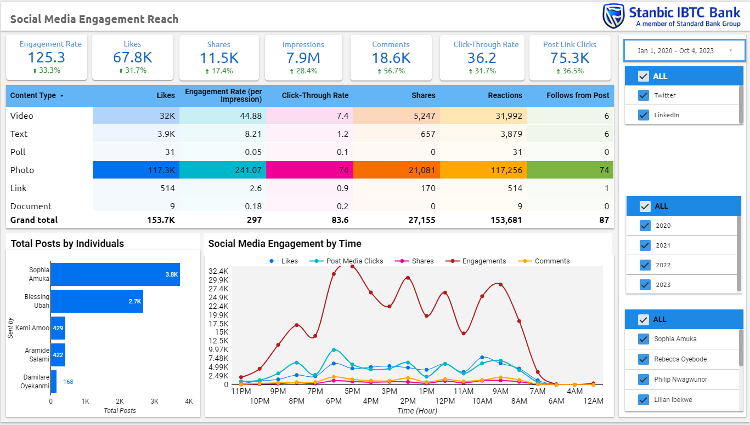

Link to the dashboard: <https://lookerstudio.google.com/s/qyEB972EpJE>